Wavelets

**Time-domain representations**: Analysis of signals with respect to time. The time-domain shows how the signal changes with time.

**Frequency-domain representations**: Analysis of signals with respect to frequency. The frequency-domain shows how much of a signal lies within each given frequency band over a range of frequencies

**Time-frequency domain representations:** comprises those techniques that study a signal in both the time and frequency domains simultaneously using different representations

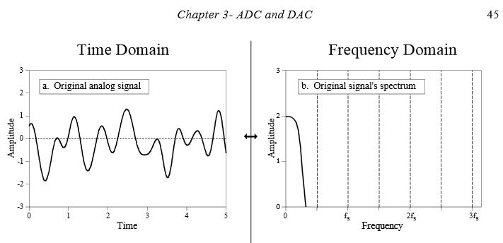

In the time domain signals appear as sinusoidal waves

In the frequency domain signals appear as distinct impulses

**What are wavelets?**

* Important aspect of signals is that the information of interest is a combination of transient phenomena (spike and actions potentials) and diffuse phenomena (small oscillations)
* These phenomena are characterized by local information that exist in the time and frequency domains
* The most common analysis methods are wavelet transform and wavelet-packet transform
* **Wavelets divide the signal of interest into different frequency components, whereby each component may be studied at a resolution matched to its scale**

All wavelet families are made of a father and mother wavelet

**Father wavelets** – Good at representing smooth and low-frequency parts of a signal

**Mother wavelets** – Good at representing detail and high-frequency parts of a signal

Wavelet decomposition

Wavelets can be utilized to decompose a signal into a low pass filter (father wavelet) and a high pass filter (mother wavelet)

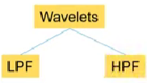

From here we can keep decomposing the low passes using a low pass and high pass filter.

Example:  
- Let’s assume our sampling frequency is 256Hz

This means the highest frequency in our signal is half of that = 128Hz

From here we can pass our signal through a high pass filter and keep decomposing the left side. Below is an illustration of this using a 128Hz signal

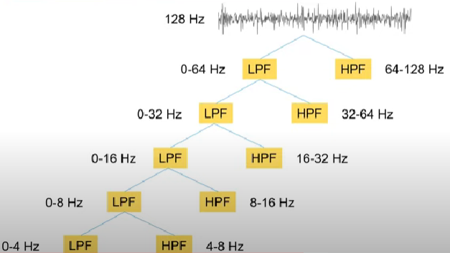

From here we can look at our EEG Bands

|  |  |
| --- | --- |
| EEG Band | Frequency Range |
| Delta | 0.5 – 4Hz |
| Theta | 4 – 8Hz |
| Alpha | 8 – 12Hz |
| Beta | 12 – 30Hz |
| Gamma | >35Hz |

If we wanted to analyse the delta frequency band, we could look into our 0-4Hz signal that was decomposed from the original signal.

*How do we extract features from this?*

So far, we’ve made mini signals that are focused inside certain frequency bands (0-4Hz mini signal = Delta band, 4-8Hz mini signal = Theta band, etc)

Now from these mini signals we can extract features that will represent the features of each frequency band i.e.

We could extract the energy of the 0-4Hz mini signal which would in turn represent the energy of the Delta frequency band.

Other features that could be extracted are variance, standard deviation, waveform length, skewness, kurtosis, range, max, etc

*What are the problems with this kind of wavelet transform?*

If we want to extract features from the alpha band, we don’t have an accurate signal that covers the frequency range. We have 8-16Hz as opposed to 8-12Hz which isn’t exactly what we want.

**This is where the wavelet packet transform is better**

Wavelet Packet Transform

In wavelet packet transform, we decompose both the low pass filters and the high pass filters at every stage as opposed to just the low pass filters.

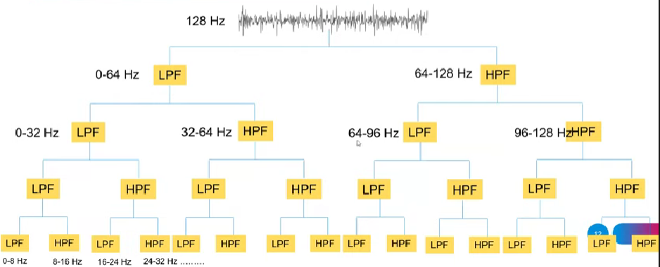

This gives us more control over the different frequency bands with respect to the mini signals that we have created.

Multi-channel EEG problem

If we have 128 EEG channels, and 6 features per channel we are going to have 768 features in total which is a lot (even more if we opt for wavelet packet transform instead of normal wavelet transform)

Solution: Use dimensionality reduction (PCA, LDA, ULDA, NPW, etc)  
Solution: Feature selection (features will be more meaningful)